**CPW is in the process of​ implementing a new licensing, pass, registration and reservation system. ​  
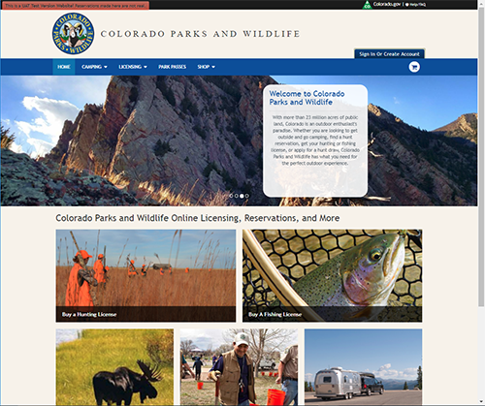**

**All purchasing will be unavailable for a few days beginning January 1, 2018. All customers will need to have an individual email address and password to apply for or purchase CPW products with the new system.**[**Make sure your current contact information and email are up to date**](http://cpw.state.co.us/updateinfo)**​ with us.​**

**​​​​​​​​**

​​​ 

​​​​​​​​​​​​​​​

**FREQUENTLY ASKED QUESTIONS ABOUT OUR NEW   
INTEGRATED PURCHASING SYSTEM**

**General System Information**

**Upcoming Timeline**

System blackout begins: January 1, 2018

Go-live: 1st weekend of January, 2018

2018 Spring Turkey apps accepted: January 10th

2018 Habitat Stamp available: January 10th

**What is the new system?**

This new integrated purchasing system will now be a one-stop shop for all items that can be purchased from Colorado Parks and Wildlife. This includes all hunting and fishing licenses and required stamps, annual parks passes, camping reservations and merchandise.

**What does it replace?**

The system combines a​​nd improves upon legacy systems previously used for purchases and customer service​​.

**Why is CPW moving to the​ new system?**

Combining all purchasing and customer service into one system allows CPW to provide better customer service and a more streamlined purchasing experience. All customers will now have one system and one account for any purchases from CPW.

**What makes this better for customers?**

* All customers will now have one system and account for any and all purchases from CPW.
* Customers can look up past and current purchases, application history and preference points all in one place.
* ​​​Hunters ​can change their applications themselves up until the draw deadline, ensuring that the application goes through the draw exactly as they intend

**What can I expect during the blackout period?**

During the changeover to our new system, customers will not be able to make any purchases online or at our offices, parks or sales agents.

All purchases will be impacted, including:

* Camping, cabin and yurt reservations
* Online hunter education, including mountain lion exams
* Hunter reservation system
* All license purchases (Including waterfowl stamps)
* Habitat stamps
* Online park pass sales
* Registration renewals
* Online retail orders
* Online license purchases

**What if I don't have an email address?**

​You will need to have an email address to make purchases online. G​mail​, Ou​tlook and Ya​h​​o​o!​ all offer free, easy-to-use email services.​

Having an email address on file allows us to send receipts, draw status, reservation confirmations and special alerts if needed. Additionally, your email address will be your login should you choose to make online purchases in the future​.​​​​

You may purchase or apply over the phone without and email address. However, you will not receive email receipts or notifications such as draw results.

If buying/applying by phone for yourself and your child, your email does not need to be unique. You can use the same email for all profiles.

**​What can I do if I don't have a credit card?​​​**

You may still use cash, check, debit, pre-paid Visa or Mastercard​​ or credit card to make in-person purchases at license agents, [parks or Colorado Parks and Wildlife offices](http://cpw.state.co.us/aboutus/Pages/ContactUs.aspx)​. Parks and CPW offices will also accept gift certificates as payment. However, all online and phone transactions require a credit card or a gift certificate issued from the new system.

If you draw a license and do not have a credit card, you will have until the payment deadline to pay for your license. If you do not pay by the deadline the license and any preference points used to draw will be surrendered to CPW.

*Payment deadline will be added shortly.*

**​Where can I find updates during the blackout period?**

​During this transition, you can [visit our blog​](http://cpw.state.co.us/aboutus/ipaws/default.aspx), which will be detailing our prog​​ress​​​ and sharing updates as the transition team has them.

​

​ 

​​​​​​​​​​​​​​​​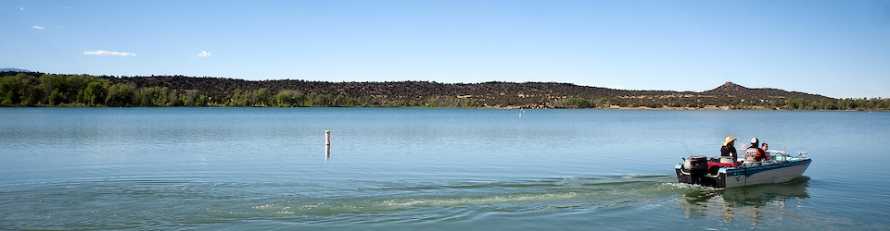

​

**Hunting and Angling**

**What do I need to buy a license online?**

* Every hunter and angler,**including youth**, will need both a unique email address and password to buy or apply for a license online.
* **Existing CPW license holders** will need their Customer Identification number (CID) (from a previous CPW license), their birthdate and a unique identifier (like a driver's license or passport) to look up their previous CPW record and create a new account.
* **New CPW license customers** will need to create an account, entering their email and creating a password, as well as providing contact and identification information the first time they use the system. New customers are able to create an account and receive a CID during business hours by calling any CPW office or the main telephone number, 303-297-1192 ahead of the system blackout.

**How do I apply for a Big Game or Turkey hunting license?**

* Starting in 2018, all resident and nonresident applications for all big game, including sheep, goat, moose and turkey will only be accepted online and by phone: 1-800-244-5613
* How to log into the new system: Use the links on any of the applicable pages at [cpw.state.co.us​](http://cpw.state.co.us/) or [log directly into the new system​](http://www.cpwshop.com/).​​

**How do I apply as part of a group?**

* One person must be the group leader and all applications in that group are linked together with that group leader’s CID.
* The group leader must apply first so that the group members’ hunt code choices can be validated.
  + Group applications for any number of people are accepted for the primary draw for elk, deer, pronghorn, bear, and turkey.
  + Group applications for up to two individuals are accepted for Rocky Mountain bighorn sheep and mountain goat. Residents and nonresidents may not apply together as a group for these species.
  + Group applications are not accepted for moose, desert bighorn sheep, or any leftover draw.
* For full details, see our [Group Hunt Applicat​​ion FAQs for 2018 ​](http://cpw.state.co.us/Documents/Hunting/BigGame/2018GROUP_HUNT_FAQ.pdf)

​

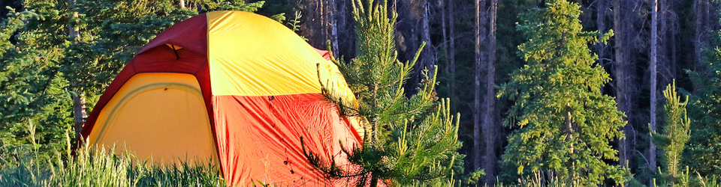​

**​State Parks and Camping​**

**What do I need to buy a parks pass online?**

* Parks pass purchasers ​​*​​*will be considered new customers in the updated system.
* All new CPW customers will need to create an account, entering their email and creating a password, as well as providing contact and identification information the first time they use the new purchasing and reservations system.

**What do I need to get a camping reservation online?**

* **Existing Reserve America and Colorado camping customers** can use their existing email and password to pull up their previous CPW record. New identifiers, including birth date and driver's license, will need to be added to your account before a reservation can be made.​
* **New customers** will need to create an account, including entering their contact and identification information, as well as an email and password, the first time they use the new system.

**When can I make my reservations?**

* If your camping plans are taking place within six months of today’s date, you may make those reservations now. This rolling reservation date window remains in place through December 31st, 2017.
* If any date of your camping plans fall outside of six months from today’s date, through December 31, 2017, you will **not** be able to make a reservation until the system changeover is complete. After launch, the six month reservation window will re-open.

**What do I need to buy a retail item like a hat, patch, or subscription to Colorado Outdoors?**

* Retail and publications customers will be considered new customers in the updated system.
* All new CPW customers will need to create an account, entering their email and creating a password, as well as providing contact and identification information the first time​​ they use the new purchasing and reservations system.​

​